Rock Cycle

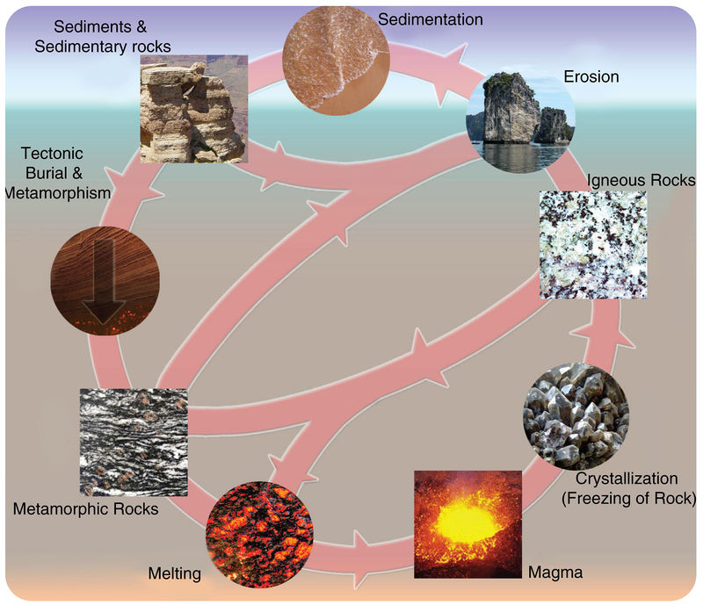

Word Bank:

Metamorphic rock tectonic burial & metamorphism
Igneous rock erosion
Sedimentary rock melting
magma crystallization
sediments

